Sirena SUPER 30 Program

VOLUME 1

COORDINATE SYSTEMS & ROBOT KINEMATICS

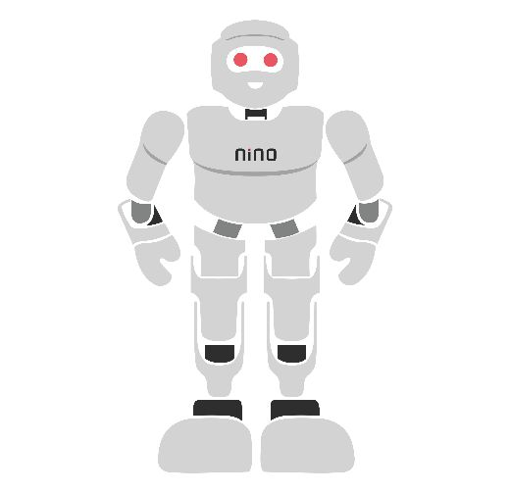

Module Overview
In modern robotics, spatial understanding is the prerequisite for all autonomous physical interaction. A robotic manipulator cannot pick up a target object, weld a car chassis, or perform surgical manipulation without precisely calculating where its end-effector is relative to the target in 3D space.
This module delivers a comprehensive, mathematically rigorous, and physically grounded education in Robotic Coordinate Systems and Kinematics. Learners study how spatial reference frames are defined, how rigid body links are interconnected by kinematic joints, how mobility (Degrees of Freedom) is calculated via the Kutzbach-Grübler criterion, and how transformations between joint space (θ1, θ2, …, θn) and Cartesian task space (X, Y, Z, Roll, Pitch, Yaw) are derived using the Denavit-Hartenberg (DH) convention, Forward Kinematics (FK), and Inverse Kinematics (IK).
Every concept transitions seamlessly from linear algebra and vector geometry to dual-platform firmware implementation on both a 5V, 8-bit AVR architecture (Arduino Uno) and a 3.3V, 32-bit dual-core architecture (ESP32). Each section concludes with a hands-on lab exercise. The module culminates in a capstone project: KinemaBot, a 3-DoF autonomous robotic arm positioning hub featuring real-time inverse kinematics trajectory planning and dual-MCU checksummed UART telemetry.
# | Topic | Hands-on Lab Focus
1 | Coordinate Systems & Reference Frames | Forward Frame Transformation Calculator & 3D Translation Matrix Engine
2 | Degrees of Freedom (DOF) & Mobility | Spatial Mechanism Mobility & Joint Limit Boundary Analyzer
3 | Kinematic Links and Joints | Multi-Joint Kinematic Chain Modeling & Software Joint Lockout System
4 | Forward Kinematics & DH Convention | 3-DoF Robotic Arm Forward Kinematics Matrix Solver
5 | Inverse Kinematics & Arm Movement | Closed-Form Analytical IK Solver & Smooth Trajectory Profile Generator
6 | Robot Arm Actuation & Feedback | Closed-Loop Multi-Axis Servo Arm Positioning Controller
7 | System Integration: KinemaBot | Dual-MCU Autonomous 3-DoF Manipulator Positioning & Telemetry Hub

Learning Outcomes
By the end of this module, learners will be able to:
- Explain Spatial Reference Frames: Define World, Base, Joint, Wrist, and Tool Center Point (TCP) coordinate frames, and express rigid-body positions and orientations using 3×3 rotation matrices (SO(3)) and 4×4 homogeneous transformation matrices (SE(3)).
- Calculate Mechanism Degrees of Freedom (DOF): Apply the Kutzbach-Grübler mobility criterion equation M = 6(n−1) − Σ(6−fi) to evaluate planar and spatial robotic mechanisms, identifying redundant and underactuated configurations.
- Classify Kinematic Links & Joints: Differentiate between Revolute (R), Prismatic (P), Cylindrical (C), Spherical (S), and Universal (U) joints, mapping joint parameter variations to spatial workspace volumes.
- Assign Denavit-Hartenberg (DH) Frames: Formulate standard DH parameter tables (di, θi, ai, αi) for arbitrary multi-joint serial manipulators and compute overall end-effector transformation matrices T₀ᴺ = A₁A₂…Aₙ.
- Solve Forward & Inverse Kinematics: Write algebraic equations and geometric closed-form solutions to map joint angles (θ1, θ2, θ3) into 3D Cartesian coordinates (X, Y, Z), and vice versa, identifying workspace singularities where the Jacobian matrix loses rank.
- Generate Smooth Arm Trajectories: Implement polynomial (cubic and quintic) and trapezoidal velocity profiles in C++ to move robot arm joints smoothly without step-loss, jerk, or mechanical vibration.
- Interface Servo Actuators & Feedback Sensors: Connect PWM servo motors, quadrature encoders, and motor drivers safely to Arduino Uno (5V) and ESP32 (3.3V) hardware using optocouplers and level shifters.
- Architect a Dual-MCU Robot Arm Controller: Integrate kinematic calculations, joint servo driving, and checksummed UART telemetry into an autonomous multi-board robotic system (KinemaBot).

Hardware and Software Required

Equipment Category | Specific Item / Description | Qty | Purpose & Specifications
Microcontrollers | Arduino Uno R3 (ATmega328P) | 1 | 5V Logic, 16 MHz, 6 PWM channels; Joint Servo Driver node
Microcontrollers | ESP32 DevKitC v4 (WROOM-32) | 1 | 3.3V Logic, 240 MHz Dual Core, FPU; Trajectory & IK Planner
Robotic Actuators | MG996R Metal Gear Servos | 3 | 11 kg·cm torque, 5V–7.2V power, position control
Robotic Actuators | SG90 Micro Servo | 1 | 1.8 kg·cm torque, end-effector gripper actuation
Manipulator Frame | 3-DoF Robotic Arm Kit | 1 | Aluminum/Acrylic links, base rotation, shoulder, elbow
Feedback Sensors | Rotary Quadrature Encoders | 2 | 20 CPR mechanical/optical encoder for joint feedback
Feedback Sensors | MPU6050 6-DoF IMU | 1 | End-effector orientation verification via I2C (0x68)
Power Supply | 5V / 6V 5A High-Current DC | 1 | External high-current power supply for servo motors
Core Electronics | Resistors, Dividers, Capacitors | 1 set | 1 kΩ, 2 kΩ level shifters, 1000 µF decoupling capacitors
Software Tools | Arduino IDE 2.x, Wokwi, Python | Free | C++ toolchain, Wokwi simulator, Python Matplotlib 3D arm plotter

1. Coordinate Systems & Reference Frames

1.1 Spatial Position and Orientation
In robotics, every physical component — whether it is the mobile robot base, a joint axis, or an end-effector welding tip — must be defined in 3D space relative to a known reference point. A complete description of a rigid body requires Position (where it is) and Orientation (how it is turned).
- Position Vector (P): a 3×1 column vector P = [Px, Py, Pz]ᵀ giving the coordinates of the origin of Frame B relative to Frame A.
- Orientation Matrix (R): a 3×3 rotation matrix whose columns are the direction cosines of Frame B's principal axes (X̂B, ŶB, ẐB) projected onto Frame A's axes (X̂A, ŶA, ẐA).
Key properties of rotation matrices (the Special Orthogonal Group SO(3)):
- Orthonormality: every column (and row) is a mutually perpendicular unit vector.
- Inverse equals Transpose: ᴮRₐ = (ᴬRʙ)⁻¹ = (ᴬRʙ)ᵀ.
- Determinant equals +1: det(R) = +1 (preserves right-handed coordinate rules).

1.2 Canonical Elementary Rotations
Rotations around principal coordinate axes by an angle θ are defined by elementary matrices:
Rotation around X-axis: Rx(θ) = [[1, 0, 0], [0, cosθ, −sinθ], [0, sinθ, cosθ]]
Rotation around Y-axis: Ry(θ) = [[cosθ, 0, sinθ], [0, 1, 0], [−sinθ, 0, cosθ]]
Rotation around Z-axis: Rz(θ) = [[cosθ, −sinθ, 0], [sinθ, cosθ, 0], [0, 0, 1]]

1.3 Homogeneous Transformation Matrices (SE(3))
To combine both rotation (R) and translation (P) into a single matrix multiplication, roboticists use a 4×4 homogeneous transformation matrix T belonging to the Special Euclidean Group SE(3):
ᴬTʙ = [ ᴬRʙ ᴬPʙ ; 0 0 0 1 ] — a 4×4 matrix with the 3×3 rotation block, the 3×1 position column, and a homogeneous bottom row [0 0 0 1].
A point PB = [XB, YB, ZB, 1]ᵀ expressed in Frame B is transformed into Frame A coordinates PA by PA = ᴬTʙ × PB. The inverse of a homogeneous transformation is calculated analytically without full matrix inversion:
ᴬTʙ⁻¹ = [ (ᴬRʙ)ᵀ , −(ᴬRʙ)ᵀ·ᴬPʙ ; 0 0 0 , 1 ].

1.4 Hierarchical Robot Frame Architecture
A complete industrial robot manipulator features a chain of coordinate frames:
- World Frame (FW): a fixed global reference frame tied to the factory floor.
- Base Frame (F₀): located at the stationary mounting base of the robot arm.
- Joint Frames (F₁, F₂, …, Fₙ): attached dynamically to each moving link along the kinematic arm chain.
- Wrist/Flange Frame (FW): attached to the final mechanical mounting flange.
- Tool Center Point Frame (FTCP): located at the operational tip of the gripper, welding torch, or suction cup.
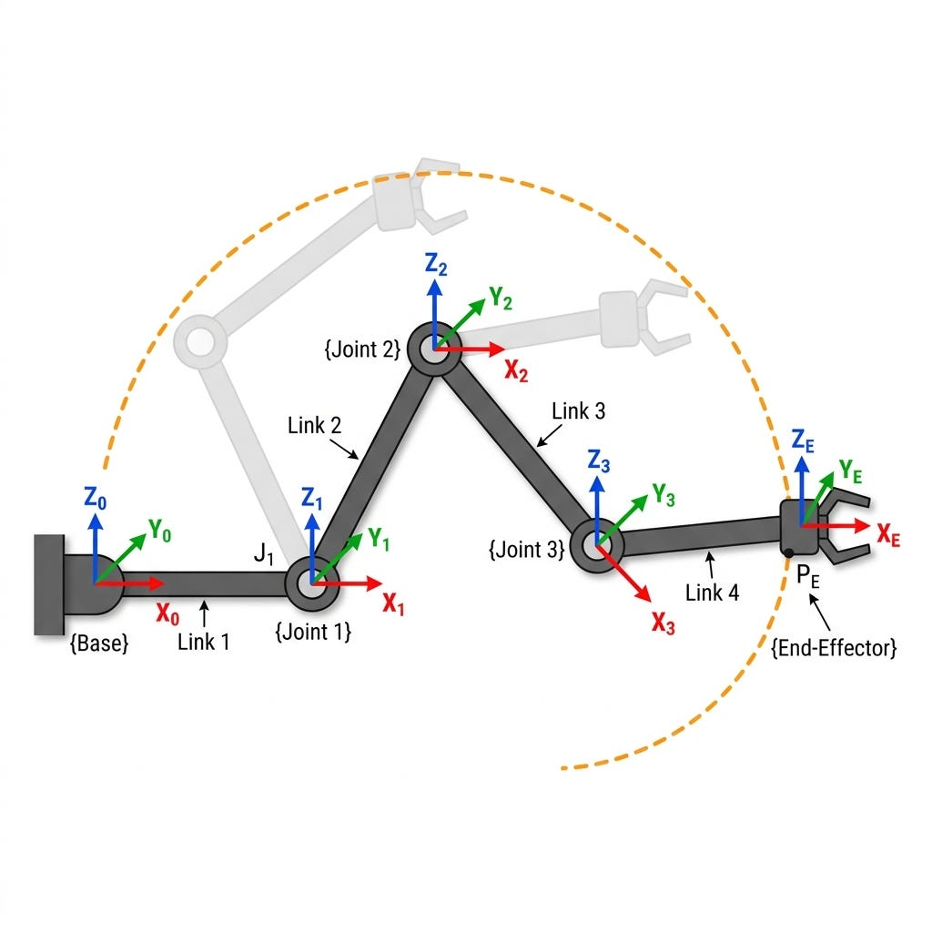
Figure 1: Hierarchical frame architecture of a serial manipulator: base frame, joint frames, and end-effector (TCP) frame with the workspace envelope.

Lab Exercise 1: Forward Frame Transformation Calculator & 3D Translation Matrix Engine
Objective: To implement a production-grade 4×4 homogeneous transformation matrix library in C++, execute sequential 3D translation and Z-axis rotation transformations, and compute the absolute spatial position of an end-effector tip relative to the robot base frame.
Wiring & Setup: Connect board USB to PC for Serial Monitor output at 115200 baud. No external hardware is required for this mathematical matrix engine lab.
/*
* Lab Exercise 1: 4x4 Homogeneous Transformation Matrix Engine
* Dual Architecture Compatibility: Arduino Uno & ESP32
*/
struct Point3D { float x; float y; float z; };
struct Matrix4x4 { float m[4][4]; };
Matrix4x4 createIdentity() {
Matrix4x4 mat;
for (int i = 0; i < 4; i++)
for (int j = 0; j < 4; j++)
mat.m[i][j] = (i == j) ? 1.0 : 0.0;
return mat;
}
Matrix4x4 createTranslation(float tx, float ty, float tz) {
Matrix4x4 mat = createIdentity();
mat.m[0][3] = tx; mat.m[1][3] = ty; mat.m[2][3] = tz;
return mat;
}
Matrix4x4 createRotationZ(float angleDeg) {
Matrix4x4 mat = createIdentity();
float rad = angleDeg * (3.14159265 / 180.0);
float c = cos(rad), s = sin(rad);
mat.m[0][0] = c; mat.m[0][1] = -s;
mat.m[1][0] = s; mat.m[1][1] = c;
return mat;
}
Matrix4x4 multiplyMatrices(Matrix4x4 A, Matrix4x4 B) {
Matrix4x4 C;
for (int i = 0; i < 4; i++)
for (int j = 0; j < 4; j++) {
C.m[i][j] = 0.0;
for (int k = 0; k < 4; k++)
C.m[i][j] += A.m[i][k] * B.m[k][j];
}
return C;
}
Point3D transformPoint(Matrix4x4 T, Point3D p) {
Point3D res;
res.x = T.m[0][0]*p.x + T.m[0][1]*p.y + T.m[0][2]*p.z + T.m[0][3];
res.y = T.m[1][0]*p.x + T.m[1][1]*p.y + T.m[1][2]*p.z + T.m[1][3];
res.z = T.m[2][0]*p.x + T.m[2][1]*p.y + T.m[2][2]*p.z + T.m[2][3];
return res;
}
void setup() {
Serial.begin(115200);
while (!Serial && millis() < 2000);
Serial.println(F("LAB 1: HOMOGENEOUS TRANSFORMATION MATRIX ENGINE"));
Matrix4x4 RotZ = createRotationZ(45.0);
Matrix4x4 Trans = createTranslation(10.0, 5.0, 0.0);
Matrix4x4 T_0_1 = multiplyMatrices(Trans, RotZ); // T = Trans * RotZ
Point3D pTool = {5.0, 0.0, 0.0};
Point3D pBase = transformPoint(T_0_1, pTool);
Serial.print(F("Tool Tip in Base: X=")); Serial.print(pBase.x, 2);
Serial.print(F(" Y=")); Serial.print(pBase.y, 2);
Serial.print(F(" Z=")); Serial.println(pBase.z, 2);
}
void loop() {}

Expected Output: The Serial Monitor outputs the 4×4 transformation matrix and prints the mapped point coordinates (X = 13.54 cm, Y = 8.54 cm, Z = 0.00 cm), verifying homogeneous spatial translation.

2. Degrees of Freedom (DOF) & Mechanism Mobility Analysis

2.1 Spatial vs Planar Workspace Degrees of Freedom
The Degrees of Freedom (DOF) or Mobility (M) of a robotic system is the minimum number of independent input parameters (joint variables) required to completely specify the spatial location and orientation of every link in the mechanism. Unconstrained rigid bodies possess maximum natural degrees of freedom:
- Unconstrained Planar Rigid Body: 3 DOF — 2 translational (X, Y) and 1 rotational (θz).
- Unconstrained Spatial Rigid Body: 6 DOF — 3 translational (X, Y, Z) and 3 rotational (Roll φ, Pitch θ, Yaw ψ).

2.2 The Kutzbach-Grübler Mobility Criterion
Spatial mechanism mobility formula:
M = 6(n − 1) − Σᵢ₌₁ʲ (6 − fᵢ)
- M = Mobility / total degrees of freedom of the mechanism.
- n = total number of links (including the stationary ground base link).
- j = total number of kinematic joints connecting the links.
- fᵢ = degrees of relative motion permitted by joint i (e.g., fᵢ = 1 for a 1-DoF revolute or prismatic joint).
For mechanisms constrained to move strictly within a 2D plane: M = 3(n − 1) − Σᵢ₌₁ʲ (3 − fᵢ).

2.3 Worked Mobility Calculation Examples
Example A — 3-Link Planar Arm (3 Revolute Joints):
n = 4 links (Base Link 0, Links 1–3), j = 3 revolute joints (f₁ = f₂ = f₃ = 1).
M = 3(4−1) − 3(3−1) = 9 − 6 = 3 DOF — the mechanism requires exactly 3 joint actuators to uniquely position and orient the end-effector.
Example B — 6-Axis Industrial Manipulator (PUMA / FANUC Style):
n = 7 links (Base + 6 moving links), j = 6 1-DoF revolute joints.
M = 6(7−1) − 6(6−1) = 36 − 30 = 6 DOF — achieves full 6-DoF spatial positioning and orientation in 3D space.

2.4 Redundant and Underactuated Robots
- Underactuated Manipulator (M < 6): fewer than 6 DOF (e.g., a 4-DoF SCARA robot); cannot achieve arbitrary orientations in full 3D space.
- Fully Actuated Manipulator (M = 6): exactly 6 DOF, allowing arbitrary positioning (X, Y, Z) and orientation (Roll, Pitch, Yaw).
- Redundant Manipulator (M > 6): more than 6 DOF (e.g., 7-DoF human-like robotic arms); redundancy allows the robot to reach a target point while avoiding internal collisions or singular joint configurations.

Lab Exercise 2: Spatial Mechanism Mobility & Joint Limit Boundary Analyzer
Objective: To build a software mobility evaluator in C++ that takes mechanical link counts, joint constraints, and joint angle software safety limits, calculates system Mobility (M), and validates whether proposed joint movement vectors violate physical hardware boundaries.
struct JointLimits { float minAngleDeg; float maxAngleDeg; };
// 3-DoF Arm Joint Limits (Base, Shoulder, Elbow)
const JointLimits ARM_LIMITS[3] = {
{-90.0, 90.0}, // Joint 1: Base Swivel
{ 0.0, 135.0}, // Joint 2: Shoulder Pitch
{-135.0, 0.0} // Joint 3: Elbow Pitch
};
int calculateSpatialMobility(int numLinks, int num1DoFJoints) {
return 6 * (numLinks - 1) - (num1DoFJoints * (6 - 1));
}
bool validateJointAngles(float q1, float q2, float q3) {
float target[3] = {q1, q2, q3};
for (int i = 0; i < 3; i++) {
if (target[i] < ARM_LIMITS[i].minAngleDeg ||
target[i] > ARM_LIMITS[i].maxAngleDeg) {
Serial.print(F("VIOLATION: Joint ")); Serial.print(i + 1);
Serial.println(F(" exceeds limits!"));
return false;
}
}
return true;
}
void setup() {
Serial.begin(115200);
while (!Serial && millis() < 2000);
int m3DoF = calculateSpatialMobility(4, 3);
Serial.print(F("Spatial Mobility (3-Joint Arm): ")); Serial.println(m3DoF);
// Target 1 (safe): [45, 60, -45] -> TARGET ACCEPTED
// Target 2 (unsafe): [45, 160, -45] -> TARGET REJECTED (Joint 2 > 135 deg)
validateJointAngles(45.0, 60.0, -45.0);
validateJointAngles(45.0, 160.0, -45.0);
}
void loop() {}

Expected Output: The mobility calculator reports 3 DOF for the four-link arm. Trajectory Target 1 is accepted as safe, while Target 2 is rejected because Joint 2 (160°) exceeds the 135° shoulder limit, blocking the command before it can reach the servo hardware.

3. Kinematic Links and Joints
A robot arm is a chain of rigid structural members (Links) connected by movable mechanical constraints (Joints). Understanding each joint type and its permitted motion is the foundation of every kinematic model.

3.1 Kinematic Joint Classification
Joint Type | Symbol | DoF | Description & Examples
Revolute | R | 1 (variable θ) | Relative rotation between two links around a single axis. Examples: elbows, shoulders, servo shafts.
Prismatic | P | 1 (variable d) | Linear sliding motion along a single axis. Examples: hydraulic rams, linear gantry slides.
Cylindrical | C | 2 | Independent rotation and translation along a single axis.
Screw/  Helical | H | 1 | Coupled rotation and translation (rotation is proportional to translation).
Spherical | S | 3 | Ball-and-socket joint permitting 3 independent rotational degrees of freedom. Examples: human hip/shoulder joints.

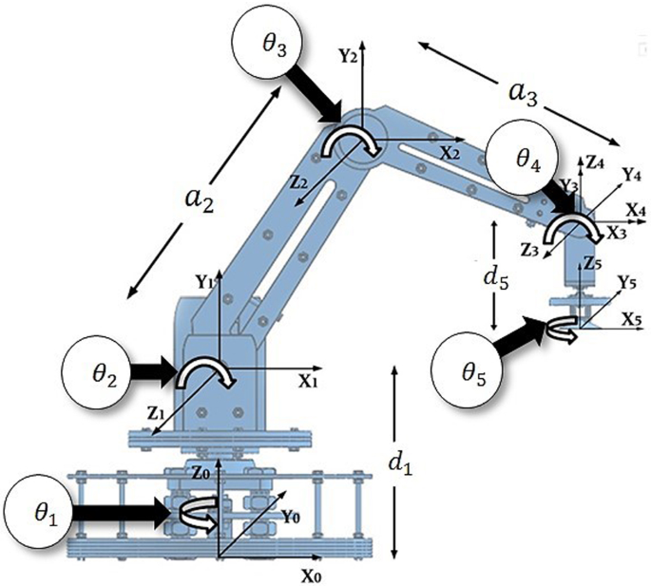
Figure 2: A multi-axis articulated manipulator with DH frames F₀…F₅ assigned along the base, shoulder, elbow and wrist joints.

3.2 Joint Space vs Task Space
Kinematic motion operates in two distinct mathematical domains:
- Joint Space (q): the vector of internal joint variables — q = [θ1, θ2, …, θn]ᵀ for revolute joints (degrees/radians), or q = [d1, d2, …, dn]ᵀ for prismatic joints (meters/mm).
- Task Space / Cartesian Space (X): the position and orientation of the end-effector tool in the external operational world: X = [X, Y, Z, Roll, Pitch, Yaw]ᵀ.
Forward Kinematics maps Joint Space (q) ⇒ Task Space (X). Inverse Kinematics maps Task Space (X) ⇒ Joint Space (q).

Lab Exercise 3: Multi-Joint Kinematic Chain Modeling & Joint Limit Monitoring
Objective: To construct a C++ data structure representing a 3-joint kinematic arm chain (R−R−R), store link parameters, compute joint vector states, and simulate joint position clamping in real time.
enum JointType { JOINT_REVOLUTE, JOINT_PRISMATIC };
struct KinematicJoint {
JointType type;
float currentVal; float minVal; float maxVal; float linkLength;
};
class RobotArmChain {
public:
KinematicJoint joints[3];
RobotArmChain() {
joints[0] = {JOINT_REVOLUTE, 0.0, -90.0, 90.0, 10.0}; // Base
joints[1] = {JOINT_REVOLUTE, 45.0, 0.0, 135.0, 15.0}; // Shoulder
joints[2] = {JOINT_REVOLUTE, -30.0,-135.0, 0.0, 12.0}; // Elbow
}
void setJointValue(int index, float val) {
if (index < 0 || index >= 3) return;
if (val < joints[index].minVal) joints[index].currentVal = joints[index].minVal;
else if (val > joints[index].maxVal) joints[index].currentVal = joints[index].maxVal;
else joints[index].currentVal = val;
}
};
RobotArmChain myArm;
void setup() {
Serial.begin(115200);
while (!Serial && millis() < 2000);
myArm.setJointValue(1, 180.0); // out of bounds -> clamps to 135.0
}
void loop() {}

Expected Output: Setting Joint 2 to 180° exceeds the 135° maximum, so the software clamps the value and prints a warning — demonstrating a software joint lockout that prevents hardware damage.

4. Forward Kinematics & Denavit-Hartenberg (DH) Convention
Forward Kinematics (FK) calculates the absolute spatial position and orientation of the end-effector (X, Y, Z, Roll, Pitch, Yaw) given the individual joint values (q = [θ1, θ2, …, θn]ᵀ) and known link lengths.

4.1 The Denavit-Hartenberg (DH) Standard Convention
To avoid arbitrary coordinate frame assignments along serial manipulators, Jacques Denavit and Richard Hartenberg formulated a standardized matrix convention. Every link-joint pair i is described by exactly four parameters:
Parameter | Symbol | Name | Definition
Joint Angle | θᵢ | Joint variable (revolute) | Angle from Xᵢ₋₁ to Xᵢ axis measured about Zᵢ₋₁ axis
Link Offset | dᵢ | Joint variable (prismatic) | Distance from origin Oᵢ₋₁ to the intersection of Xᵢ with Zᵢ₋₁, along Zᵢ₋₁
Link Length | aᵢ (or rᵢ) | Geometric constant | Distance from intersection of Xᵢ with Zᵢ₋₁ to origin Oᵢ, along Xᵢ
Link Twist | αᵢ | Geometric constant | Angle from Zᵢ₋₁ axis to Zᵢ axis measured about Xᵢ axis

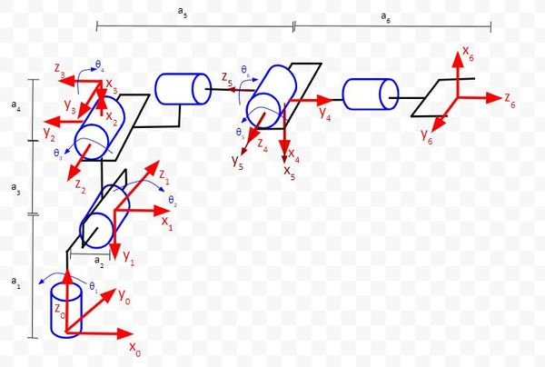
Figure 3: Systematic assignment of DH coordinate frames F₀–F₆ along a serial manipulator chain, with link lengths aᵢ and offsets dᵢ marked.

4.2 Standard DH Frame Assignment Algorithm
- Label all joint axes as Z₀, Z₁, …, Zₙ₋₁. Joint axis i executes rotation/translation along Zᵢ₋₁.
- Establish origin O₀ at Base Frame F₀. Set Z₀ aligned with Joint 1 rotation axis.
- For each frame i from 1 to N−1: set Xᵢ perpendicular to both Zᵢ₋₁ and Zᵢ; if Zᵢ₋₁ and Zᵢ intersect, direct Xᵢ away from the intersection; set Yᵢ using the right-hand rule (Yᵢ = Zᵢ × Xᵢ).
- Formulate the DH parameter table containing dᵢ, θᵢ, aᵢ, αᵢ for each link i.

4.3 Link Transformation Matrix (Aᵢ)
The individual homogeneous transformation matrix Aᵢ relating frame i to frame i−1 is the product of four basic transformations:
Aᵢ = Rot_z(θᵢ) × Trans_z(dᵢ) × Trans_x(aᵢ) × Rot_x(αᵢ)
Aᵢ = [ cosθᵢ, −sinθᵢcosαᵢ, sinθᵢsinαᵢ, aᵢcosθᵢ ; sinθᵢ, cosθᵢcosαᵢ, −cosθᵢsinαᵢ, aᵢsinθᵢ ; 0, sinαᵢ, cosαᵢ, dᵢ ; 0, 0, 0, 1 ]
The total forward kinematic transformation matrix from base to end-effector is the chained product:
T₀ᴺ = A₁ × A₂ × A₃ × … × Aₙ

Lab Exercise 4: Forward Kinematics Engine for a 3-DoF Planar Robotic Arm
Objective: To implement a complete DH transformation solver in C++ for a 2D/3D 3-DoF planar arm with link lengths L₁ = 10 cm, L₂ = 10 cm, L₃ = 5 cm, and compute end-effector position (X, Y) for any arbitrary joint vector (θ₁, θ₂, θ₃).
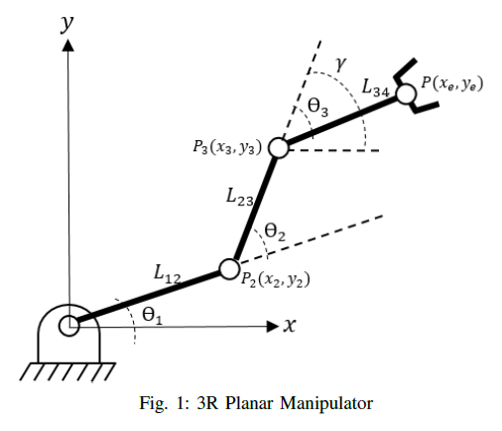
Figure 4: Geometry of a 3R planar manipulator: cumulative angles θ₁₂ and θ₁₂₃ position joints P₂, P₃ and the end-effector P(xe, ye).
#include <math.h>
const float L1 = 10.0, L2 = 10.0, L3 = 5.0; // cm
struct Position2D { float x; float y; float phiDeg; };
Position2D computeForwardKinematics(float t1d, float t2d, float t3d) {
float t1 = t1d * (3.14159265 / 180.0);
float t2 = t2d * (3.14159265 / 180.0);
float t3 = t3d * (3.14159265 / 180.0);
float t12 = t1 + t2, t123 = t1 + t2 + t3;
Position2D pos;
pos.x = L1*cos(t1) + L2*cos(t12) + L3*cos(t123);
pos.y = L1*sin(t1) + L2*sin(t12) + L3*sin(t123);
pos.phiDeg = t1d + t2d + t3d;
return pos;
}
void setup() {
Serial.begin(115200);
while (!Serial && millis() < 2000);
Position2D p1 = computeForwardKinematics(0.0, 0.0, 0.0);
Serial.print(F("Test 1 (0,0,0) -> X = ")); Serial.print(p1.x, 2);
Serial.print(F(" cm, Y = ")); Serial.println(p1.y, 2);
Position2D p2 = computeForwardKinematics(45.0, 45.0, -30.0);
Serial.print(F("Test 2 (45,45,-30) -> X = ")); Serial.print(p2.x, 2);
Serial.print(F(" cm, Y = ")); Serial.println(p2.y, 2);
}
void loop() {}

Expected Output: For Test 1 (θ = [0°, 0°, 0°]) the code outputs X = 25.00 cm (10 + 10 + 5), Y = 0.00 cm and ϕ = 0.0°, mathematically verifying the trigonometric forward kinematic model.

5. Inverse Kinematics & Arm Trajectory Generation
Inverse Kinematics (IK) is the inverse operation: given a target Cartesian end-effector position (X, Y, Z), calculate the required joint variables (θ₁, θ₂, …, θₙ) to move the tool to that exact target. A 2-link arm generally has two valid solutions — an elbow-up and an elbow-down configuration — for any reachable target point.

5.1 Analytical Inverse Kinematics (Law of Cosines Approach)
Step 1 — Distance to target: r² = X² + Y².
Step 2 — Elbow angle θ₂ from the Law of Cosines:
cosθ₂ = (r² − L₁² − L₂²) / (2·L₁·L₂) ⇒ θ₂ = ±arccos[(r² − L₁² − L₂²) / (2·L₁·L₂)]
- +θ₂ yields the elbow-down configuration; −θ₂ yields the elbow-up configuration.
Step 3 — Base angle θ₁:
θ₁ = atan2(Y, X) − atan2(L₂·sinθ₂, L₁ + L₂·cosθ₂)

5.2 Workspace Singularities & Boundary Limits
A kinematic singularity occurs when the manipulator Jacobian matrix J(q) loses rank (det(J) = 0). At a singular point: the robot loses mobility in one or more Cartesian directions, and small Cartesian velocities require infinite joint velocities (q̇ → ∞). A boundary singularity occurs when the arm is fully extended (r = L₁ + L₂) or folded onto itself (r = |L₁ − L₂|).

5.3 Arm Movement & Smooth Trajectory Generation
Directly jumping joint angles from θ_start to θ_target causes infinite acceleration spikes, motor step loss, and structural shudder. Robots use trapezoidal velocity profiles or cubic/quintic polynomial interpolation. A cubic polynomial joint trajectory with zero initial and final velocity is:
θ(t) = a₀ + a₁t + a₂t² + a₃t³, with θ(0) = θ₀, θ(T) = θf, θ̇(0) = 0, θ̇(T) = 0.

Lab Exercise 5: Closed-Form Analytical IK Solver & Smooth Trajectory Generator
Objective: To implement a real-time closed-form IK solver for a 2-DoF arm (L₁ = 12 cm, L₂ = 10 cm), handle workspace out-of-bounds errors, and generate smooth interpolated trajectory steps between current and target positions.
#include <math.h>
const float L1 = 12.0, L2 = 10.0; // cm
struct JointVector { float theta1Deg; float theta2Deg; bool valid; };
JointVector solveInverseKinematics(float X, float Y) {
JointVector j;
float r2 = X*X + Y*Y, r = sqrt(r2);
if (r > (L1 + L2) || r < fabs(L1 - L2)) { j.valid = false; return j; }
float cosTheta2 = (r2 - L1*L1 - L2*L2) / (2.0 * L1 * L2);
if (cosTheta2 > 1.0) cosTheta2 = 1.0; // clamp rounding errors
if (cosTheta2 < -1.0) cosTheta2 = -1.0;
float sinTheta2 = sqrt(1.0 - cosTheta2 * cosTheta2);
float theta2Rad = atan2(sinTheta2, cosTheta2); // elbow-down branch
float k1 = L1 + L2 * cosTheta2, k2 = L2 * sinTheta2;
float theta1Rad = atan2(Y, X) - atan2(k2, k1);
j.theta1Deg = theta1Rad * (180.0 / 3.14159265);
j.theta2Deg = theta2Rad * (180.0 / 3.14159265);
j.valid = true;
return j;
}
void setup() {
Serial.begin(115200);
while (!Serial && millis() < 2000);
JointVector ik = solveInverseKinematics(15.0, 8.0); // target (15, 8)
if (ik.valid) {
for (int step = 0; step <= 5; step++) {
float t = (float)step / 5.0;
float s = 3.0*t*t - 2.0*t*t*t; // cubic smoothing factor
float q1 = ik.theta1Deg * s, q2 = ik.theta2Deg * s;
// output interpolated joint steps...
}
} else {
Serial.println(F("ERROR: Target OUTSIDE arm workspace!"));
}
}
void loop() {}

Expected Output: The solver returns valid joint angles for the reachable target (X = 15 cm, Y = 8 cm), and the trajectory interpolator emits six cubic-smoothed steps from zero to the target joint vector. Unreachable targets are rejected with a workspace error.

6. Robot Arm Actuation & Feedback Control
Robotic joints require precise electrical actuation and position feedback to execute commanded trajectory movements. A closed-loop controller compares the target angle (θ_ref) against encoder-measured shaft position and drives the servo via a PID compensator.

6.1 Servo Motor Pulse-Width Control (50 Hz)
Standard RC hobby servos (such as the MG996R or SG90) use a 50 Hz PWM frame period (20 ms). The active HIGH pulse width determines the target shaft angle:
- 0°: 1.0 ms HIGH pulse within the 20 ms frame
- 90°: 1.5 ms HIGH pulse within the 20 ms frame
- 180°: 2.0 ms HIGH pulse within the 20 ms frame
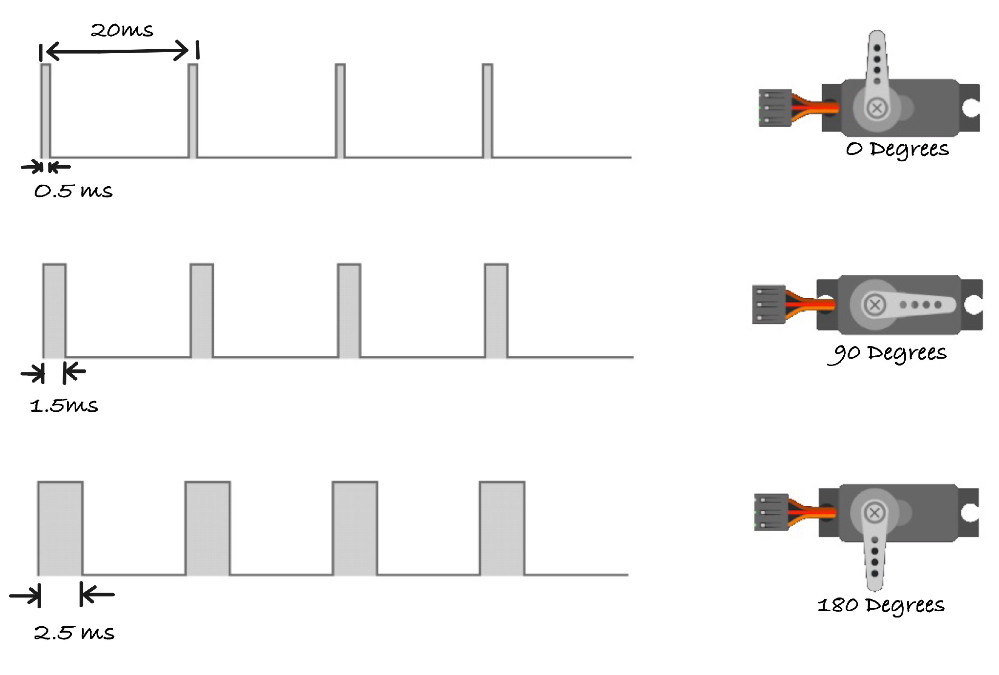
Figure 5: Servo position control: pulse widths of 0.5 ms, 1.5 ms and 2.5 ms (typical extended range) within a 20 ms (50 Hz) frame.

6.2 Dual MCU Logic Level & High-Current Servo Wiring
- Never power servos from microcontroller 5V pins: moving servos draw 500 mA to 2.5 A stall current, causing MCU brown-out resets. Always use a separate 5V–6V high-current supply.
- Common ground connection: the external servo supply ground (GND) MUST be tied directly to the MCU GND pin.
- ESP32 3.3V to 5V servo logic: most servos accept 3.3V PWM control signals directly; if signal degradation occurs, use a BSS138 MOSFET or 74HCT245 logic level shifter.
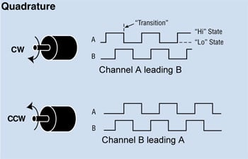
Figure 6: Quadrature encoder output: channel A leads channel B for clockwise rotation; channel B leads A for counter-clockwise rotation.

Lab Exercise 6: Closed-Loop Multi-Axis Servo Arm Controller with Position Verification
Objective: To build a multi-servo arm driver in C++, map inverse kinematics joint angles (θ₁, θ₂) to PWM pulse durations, and drive two servos smoothly without blocking loop delays.
Circuit connections — Servo 1 (Base Joint): signal to Uno Pin 9 (ESP32 GPIO 13); Servo 2 (Shoulder Joint): signal to Uno Pin 10 (ESP32 GPIO 14). Both powered from an external 5V supply with a common ground.
#if defined(ARDUINO_ARCH_ESP32)
#include <ESP32Servo.h>
const int SERVO1_PIN = 13, SERVO2_PIN = 14;
#else
#include <Servo.h>
const int SERVO1_PIN = 9, SERVO2_PIN = 10;
#endif
Servo servo1, servo2;
float currentAngle1 = 0.0, targetAngle1 = 0.0;
float currentAngle2 = 0.0, targetAngle2 = 0.0;
unsigned long lastServoStep = 0;
const unsigned long STEP_INTERVAL_MS = 15; // 1 deg every 15 ms
void setup() {
Serial.begin(115200);
while (!Serial && millis() < 2000);
#if defined(ARDUINO_ARCH_ESP32)
ESP32PWM::allocateTimer(0);
ESP32PWM::allocateTimer(1);
servo1.setPeriodHertz(50); servo2.setPeriodHertz(50);
servo1.attach(SERVO1_PIN, 500, 2400);
servo2.attach(SERVO2_PIN, 500, 2400);
#else
servo1.attach(SERVO1_PIN); servo2.attach(SERVO2_PIN);
#endif
targetAngle1 = 60.0; targetAngle2 = 45.0; // initial command
}
void loop() {
unsigned long now = millis();
if (now - lastServoStep >= STEP_INTERVAL_MS) {
lastServoStep = now;
if (currentAngle1 < targetAngle1) currentAngle1 += 1.0;
else if (currentAngle1 > targetAngle1) currentAngle1 -= 1.0;
if (currentAngle2 < targetAngle2) currentAngle2 += 1.0;
else if (currentAngle2 > targetAngle2) currentAngle2 -= 1.0;
servo1.write((int)currentAngle1);
servo2.write((int)currentAngle2);
}
}

Expected Output: Both servos move smoothly toward their commanded angles (Base 60°, Shoulder 45°) at one degree every 15 ms, while loop() remains free for sensor reading and UART communication.

7. System Integration: KinemaBot Autonomous Guidance Hub

7.1 System Requirements & Dual-MCU Architecture
The KinemaBot capstone project integrates spatial kinematics, analytical inverse kinematics, smooth trajectory interpolation, and dual-MCU inter-board serial communications into a complete 3-DoF robotic manipulator controller. The ESP32 (3.3V) runs as the Trajectory Planner: Cartesian target planning, analytical IK solving, cubic trajectory interpolation, and NMEA checksum frame encoding, all sent over UART to the Arduino Uno (5V) Joint Actuator node, which drives the three joint servos at 50 Hz and monitors a hardware emergency-stop switch.
- R1: Accept target Cartesian 3D coordinate inputs (X, Y, Z) via Serial or autonomous planner.
- R2: ESP32 calculates Inverse Kinematics joint angles (θ₁, θ₂, θ₃) using floating-point hardware.
- R3: ESP32 interpolates trajectory steps using cubic polynomial smoothing.
- R4: ESP32 packs joint steps into NMEA-style checksummed packets: $KINE,seq,q1_deg10,q2_deg10,q3_deg10*HH\r\n.
- R5: Level-shift 5V/3.3V UART signals between Uno and ESP32 safely.
- R6: Arduino Uno validates checksums and drives joint servos at 50 Hz without blocking.
- R7: Fail-safe watchdog — if no valid command arrives for 1 second, the Uno holds joint position.
Microcontroller Board | Connected Hardware Peripheral | Physical Pin Assignment | Signal Function
Arduino Uno (Joint Node) | Base Swivel Servo (Joint 1) | Digital Pin 9 (PWM) | 50 Hz Servo Control Signal
Arduino Uno (Joint Node) | Shoulder Pitch Servo (Joint 2) | Digital Pin 10 (PWM) | 50 Hz Servo Control Signal
Arduino Uno (Joint Node) | Elbow Pitch Servo (Joint 3) | Digital Pin 11 (PWM) | 50 Hz Servo Control Signal
Arduino Uno (Joint Node) | Emergency Stop Switch | Digital Pin 2 (Interrupt) | Active-Low Hardware E-Stop Input
Arduino Uno (Joint Node) | ESP32 UART Inter-Board Link | Digital Pin 7 (TX) / 6 (RX) | SoftwareSerial link to ESP32
ESP32 (Planner Node) | Arduino Uno Inter-Board Link | GPIO Pin 16 (RX2) / 17 (TX2) | HardwareSerial UART2 Link
ESP32 (Planner Node) | Status Telemetry LED | GPIO Pin 2 | Link status indicator LED

7.2 KinemaBot Trajectory Planner Firmware (ESP32)
HardwareSerial JointNodeSerial(2); // UART2: RX2=GPIO 16, TX2=GPIO 17
const float L1 = 10.0, L2 = 12.0, L3 = 10.0; // cm
unsigned int seqCount = 0;
byte calculateChecksum(const char* str) {
byte chk = 0;
while (*str) { if (*str != '$' && *str != '*') chk ^= *str; str++; }
return chk;
}
bool solve3DIK(float X, float Y, float Z, float &q1, float &q2, float &q3) {
q1 = atan2(Y, X) * (180.0 / 3.14159265); // Base swivel
float rXY = sqrt(X*X + Y*Y), zEff = Z - L1;
float r2 = rXY*rXY + zEff*zEff, r = sqrt(r2);
if (r > (L2 + L3) || r < fabs(L2 - L3)) return false; // out of reach
float cosQ3 = (r2 - L2*L2 - L3*L3) / (2.0 * L2 * L3);
float sinQ3 = sqrt(1.0 - cosQ3 * cosQ3);
q3 = atan2(sinQ3, cosQ3) * (180.0 / 3.14159265); // Elbow
float k1 = L2 + L3 * cosQ3, k2 = L3 * sinQ3;
q2 = (atan2(zEff, rXY) - atan2(k2, k1)) * (180.0 / 3.14159265); // Shoulder
return true;
}
void sendKinematicCommand(float q1, float q2, float q3) {
char payload[64];
snprintf(payload, sizeof(payload), "$KINE,%u,%d,%d,%d",
seqCount++, (int)(q1*10.0), (int)(q2*10.0), (int)(q3*10.0));
char fullFrame[80];
snprintf(fullFrame, sizeof(fullFrame), "%s*%02X", payload, calculateChecksum(payload));
JointNodeSerial.println(fullFrame);
}

7.3 KinemaBot Joint Actuator Firmware (Arduino Uno)
SoftwareSerial espLink(6, 7); // RX=D6, TX=D7
Servo joint1, joint2, joint3;
unsigned long lastValidCmd = 0;
bool verifyChecksum(const char* packet) {
const char* starPos = strchr(packet, '*');
if (!starPos) return false;
byte expectedChk = (byte)strtol(starPos + 1, NULL, 16);
byte calculatedChk = 0;
for (const char* p = packet; p < starPos; p++)
if (*p != '$') calculatedChk ^= *p;
return (calculatedChk == expectedChk);
}
void loop() {
if (espLink.available()) {
String line = espLink.readStringUntil('\n');
line.trim();
if (line.startsWith("$KINE") && verifyChecksum(line.c_str())) {
lastValidCmd = millis();
// parse q1_10, q2_10, q3_10 (angle * 10) by comma indexes...
// joint1.write(constrain((int)(q1 + 90.0), 0, 180)); etc.
}
}
}

Expected Output: The ESP32 planner solves IK for the target (X = 12 cm, Y = 8 cm, Z = 15 cm), transmits $KINE frames once per second, and the Uno validates each checksum before updating the servos. Corrupted frames are rejected and logged.

8. Review & Practice Problem Set

Problem 1 — 2D Point Rotation Matrix
Question: A point PB = [5.0, 2.0]ᵀ is expressed in Frame B, which is rotated θ = 30° counter-clockwise relative to Frame A. Compute PA.
Solution: PA = Rz(30°)·PB: XA = 0.866×5.0 − 0.500×2.0 = 3.33; YA = 0.500×5.0 + 0.866×2.0 = 4.23. PA = [3.33, 4.23]ᵀ.

Problem 2 — Homogeneous Transformation Composition
Question: Frame B is translated by P = [4.0, 0.0, 2.0]ᵀ relative to Frame A and rotated 90° about Z. Compute ᴬTʙ.
Solution: ᴬTʙ = [[0, −1, 0, 4.0]; [1, 0, 0, 0.0]; [0, 0, 1, 2.0]; [0, 0, 0, 1]].

Problem 3 — Planar Mechanism Mobility (4-Bar Linkage)
Question: A 4-bar linkage has n = 4 links and j = 4 1-DoF revolute joints. Compute M (planar Kutzbach).
Solution: M = 3(4−1) − 4(3−1) = 9 − 8 = 1 DOF — driving one joint uniquely controls the whole linkage.

Problem 4 — Spatial Robot Arm Mobility
Question: A 5-axis articulated robot has n = 6 links and j = 5 revolute joints. Compute spatial M.
Solution: M = 6(6−1) − 5(6−1) = 30 − 25 = 5 DOF.

Problem 5 — Forward Kinematics Calculation
Question: A 2-DoF planar arm has L₁ = 15 cm, L₂ = 10 cm, θ₁ = 30°, θ₂ = 45°. Compute (X, Y).
Solution: θ₁₂ = 75°. X = 15·cos30° + 10·cos75° = 12.99 + 2.59 = 15.58 cm. Y = 15·sin30° + 10·sin75° = 7.50 + 9.66 = 17.16 cm.

Problem 6 — IK Reachability Check
Question: L₁ = 20 cm, L₂ = 15 cm. Is target (25, 25) reachable?
Solution: r = √(25² + 25²) ≈ 35.36 cm > Rmax = L₁ + L₂ = 35.00 cm — the target is OUTSIDE the workspace.

Problem 7 — Servo Timer Compare Value
Question: A 10-bit PWM timer at 50 Hz (20 ms) drives a servo: 1.0 ms → 0°, 2.0 ms → 180°. Find the compare value for 90° (1.5 ms).
Solution: Counts per ms = 1023 / 20 = 51.15 counts/ms. Compare value = 1.5 × 51.15 ≈ 77 counts.

Problem 8 — Cubic Trajectory Coefficients
Question: Move θ₀ = 0° → θf = 90° in T = 2.0 s with zero initial/final velocity. Find θ(t).
Solution: a₀ = a₁ = 0; a₂ = 3(90−0)/2² = 67.5; a₃ = −2(90)/2³ = −22.5. θ(t) = 67.5 t² − 22.5 t³ degrees.

Academic & Industrial References
Craig, J. J. (2018). Introduction to Robotics: Mechanics and Control (4th ed.). Pearson.
Spong, M. W., Hutchinson, S., & Vidyasagar, M. (2020). Robot Modeling and Control (2nd ed.). Wiley.
Corke, P. (2017). Robotics, Vision and Control: Fundamental Algorithms in MATLAB (2nd ed.). Springer.
Siciliano, B., Sciavicco, L., Villani, L., & Oriolo, G. (2010). Robotics: Modelling, Planning and Control. Springer Science & Business Media.
Denavit, J., & Hartenberg, R. S. (1955). A kinematic notation for lower-pair mechanisms based on matrices. Journal of Applied Mechanics, 22(2), 215-221.
International Organization for Standardization. (2021). ISO 8373:2021 Robotics — Vocabulary. ISO.

Module Conclusion
This module progressed from spatial coordinate systems and mobility analysis to Denavit-Hartenberg parameters, forward kinematics, inverse kinematics, smooth trajectory interpolation, and closed-loop joint servo actuation — every topic implemented side-by-side on the Arduino Uno (deterministic joint servo PWM) and the ESP32 (high-speed floating-point kinematics).
The KinemaBot capstone demonstrates that professional embedded robotics practice rests on the same principles taught throughout: rigorous spatial modeling, non-blocking firmware, verified communication protocols, and fail-safe design. Integrating kinematic calculations, joint servo driving, and checksummed UART telemetry into an autonomous two-board system is direct evidence of practical robotics engineering skill.

